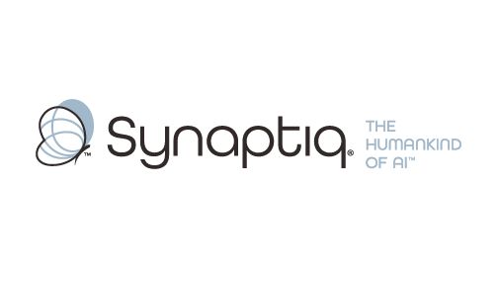
______________________________________________________________________
 | Stephen Sklarew  CEO & Co-Founder, Synaptiq  AI Strategy & Workforce Transformation | "The Humankind of AI"

Overview
Stephen Sklarew is a seasoned executive with over 30 years of experience guiding organizations through transformative AI initiatives, specializing in program management of computer vision deployments and advanced document processing/RAG systems across many industries. As CEO of Synaptiq, he has led diverse AI projects spanning quality control and safety monitoring, multi-format document processing, and enterprise-scale RAG implementations. His proven AIQ® methodology helps organizations evaluate AI readiness, navigate complex architectural decisions, and prioritize high-ROI use cases across both visual and document intelligence domains. Stephen combines deep technical understanding with strategic business insight, enabling him to translate AI capabilities into measurable outcomes while ensuring sustainable adoption across complex manufacturing operations and document ecosystems.
Background & Expertise
Stephen Sklarew is a seasoned business and technology executive with over 30 years of experience driving innovation across a wide range of technology-intensive organizations. As CEO and cofounder of Synaptiq, founded in 2015, Stephen specializes in helping established companies navigate complex AI transformations, with particular depth in computer vision applications and advanced document processing systems for operational excellence.
Stephen's experience spans the full spectrum of AI technology deployments, from initial feasibility assessment through enterprise-scale implementation. His portfolio includes computer vision projects and automated detection systems, alongside sophisticated RAG implementations handling diverse document types and multi-format processing challenges. His program management experience has given him unique insight into the common failure modes of both vision and document intelligence initiatives, the critical success factors for ROI achievement, and the organizational capabilities required for sustainable adoption across complex enterprise environments.
Prior to founding Synaptiq, Stephen held senior positions at companies like Sage Software, CEB (now Gartner), and Ernst & Young LLP, where he led innovative product and software engineering initiatives. He also cofounded CircleBack (now SalesIntel) in 2008, a data-driven SaaS platform utilizing machine learning and computer vision for aggregating business contact information.
Under Stephen's leadership, Synaptiq developed the proprietary AIQ® methodology, a comprehensive framework that addresses the organizational, technical, and cultural dimensions of AI readiness across both computer vision and document processing domains. This approach has proven particularly valuable for companies launching AI initiatives, as it helps leaders identify high-impact use cases, navigate nuanced architectural decisions, and build internal capabilities for long-term success. Stephen is committed to ethical AI development and sustainable business outcomes, exemplified by Synaptiq's philosophy of building 'The Humankind of AI' — technology that amplifies human capabilities rather than replacing human judgment.
Stephen regularly shares insights on AI transformation as a thought leader, speaker, and guest lecturer, with particular focus on helping organizations learn from others' successes and failures before making significant technology investments.

